# Events Heat Map

The main page shows the most popular events from the specified categories. It is inspired by Windows 8 Metro UI paradigm and visual indication.

Size depends on the popularity rate of the most popular event in the category (underlined). Every category has its own color. If you tap anywhere on the square you will be navigated to events map for the appropriate category.

If you click on the event link you will be navigated to the detailed description of the event at the Eventfull.com

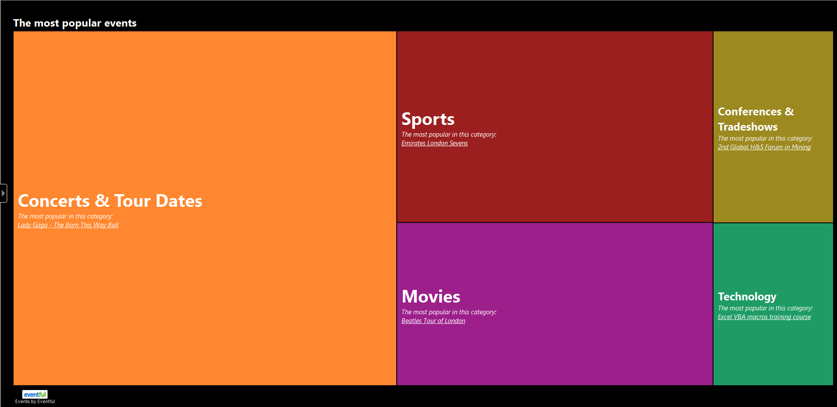

User will be able to apply a number of filters:

* Date range within he wants to see events;
* Location of the events(by default it will be user current location)
* Select necessary categories to display.

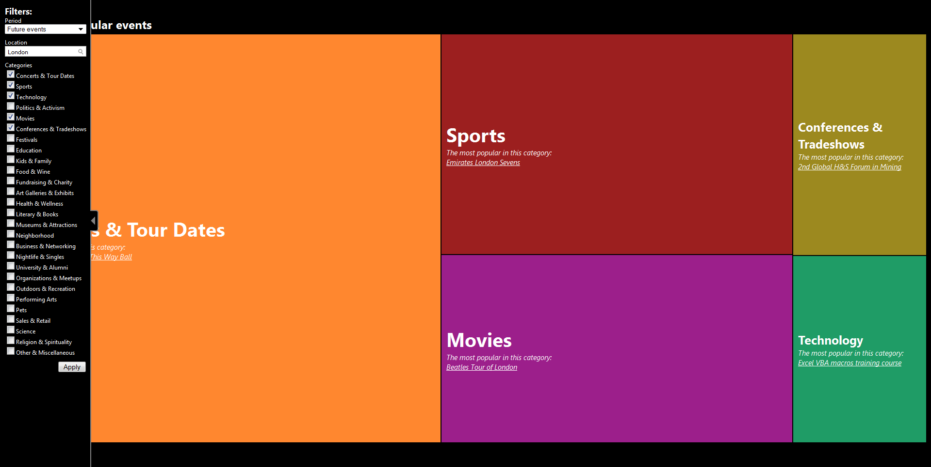

You can see more categories\events at once if you want:

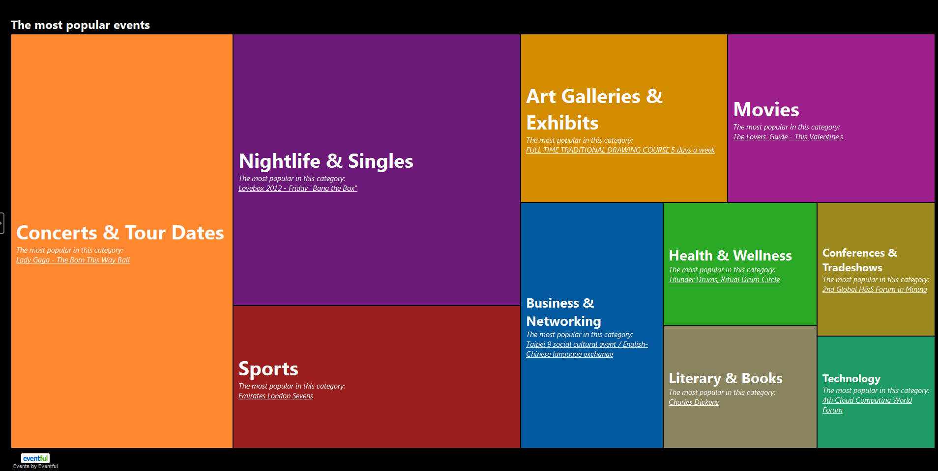

After taping on the appropriate category you can see events within this category. The bigger size of square the more popular particular event is. Color indicates start time of the event: the lighter color says that event will be very soon. You can also use filter at this page too.

You can navigate among different event types just swiping to the left (to the previous category) or to the right(to the next category):

